Lab 4

Configuring Distributed File System (DFS)

This lab contains the following exercises and activities:

|  |  |
| --- | --- |
| Exercise 4.1 | Installing DFS |
| Exercise 4.2 | Configuring DFS Namespace |
| Exercise 4.3 | Configuring DFS Replication |
| Lab Challenge | Create a Fault-Tolerant Shared Folder |

BEFORE YOU BEGIN

The lab environment consists of student workstations connected to a local area network, along with a server that functions as the domain controller for a domain called *contoso.com*. The computers required for this lab are listed in Table 4-1.

Table 4-1

Computers Required for Lab 4

|  |  |  |
| --- | --- | --- |
| Computer | Operating System | Computer Name |
| Server (VM 1) | Windows Server 2012 | RWDC01 |
| Server (VM 2) | Windows Server 2012 | Server01 |
| Server (VM 3) | Windows Server 2012 | Server02 |

In addition to the computers, you also require the software listed in Table 4-2 to complete Lab 4.

Table 4-2

Software Required for Lab 4

|  |  |
| --- | --- |
| Software | Location |
| Lab 4 student worksheet | Lab04_worksheet.rtf (provided by instructor) |

Working with Lab Worksheets

Each lab in this manual requires that you answer questions, take screen shots, and perform other activities that you will document in a worksheet named for the lab, such as Lab04_worksheet.rtf. You will find these worksheets on the book companion site. It is recommended that you use a USB flash drive to store your worksheets, so you can submit them to your instructor for review. As you perform the exercises in each lab, open the appropriate worksheet file using WordPad, fill in the required information, and save the file to your flash drive.

After completing this lab, you will be able to:

* Install DFS
* Implement and configure DFS namespace
* Implement and configure DFS replication
* Use DFS for fault tolerant shared folders

Estimated lab time: 60 minutes

|  |  |
| --- | --- |
| Exercise 4.1 | Installing DFS |
| Overview | In this exercise, you install DFS (namespace and replication) on Server01 and Server02. In the following exercises, you configure DFS. |
| Completion time | 10 minutes |

**1.** Log on to the Server01 server using the **Contoso\Administrator** account and the password **Password01**. The Server Manager console opens.

**2.** At the top of Server Manager, select Manage and click Add Roles and Features. The Add Roles and Feature Wizard opens.

**3.** On the Before you begin page, click Next.

**4.** Select *Role-based or feature-based installation* and then click Next.

**5.** When asks what server to select, click Next.

**6.** Scroll down and expand File and Storage Services and then expand File and iSCSI Services. Select File Server (if not already installed), DFS Namespace, and DFS Replication. When asked to add features to DFS Namespace, click Add Features.

**7.** When you are back on the Select server roles page, click Next.

**8.** On the Select features page, click Next.

**9.** On the Confirm installation selections, click Install.

**10.** When the installation is complete, click the Close button.

**11.** Repeat the process to install File Server, DFS Namespace, and DFS replication on Server02.

End of exercise. Close any open windows before you begin the next exercise.

|  |  |
| --- | --- |
| Exercise 4.2 | Configuring DFS Namespace |
| Overview | During this exercise, you create several shared folders and you link them together with DFS Namespace. |
| Completion time | 25 minutes |

**Mindset Question: You work for a corporation that has several file servers with multiple shared folders. You want to make it easier for users to access the shared folders. What can you do?**

**1.** On Server01, open File Explorer and create **C:\Share1** and **C:\Share2** folders.

**2.** Right-click Share1 and click Properties. The Properties dialog box opens.

**3.** Click the Sharing tab and click Advanced Sharing.

**4.** Click Share this folder check box.

**5.** Click Permissions. Click Allow Full Control for Everyone. Click OK to close the Permissions dialog box.

|  |  |
| --- | --- |
| Question 1 | Because we allow everyone full control, how do you make sure that the shared files are secure? |

**6.** Click OK to close Advanced Sharing dialog box and click Closeto close the Share1 Properties dialog box.

**7.** On Server01, repeat the process to share Share2.

**8.** On Server02, open File Explorer and create **C:\Share1** and **C:\Share2** folders.

**9.** Similar to what was done on Server01, share theShare1 and Share2 on Server02.

**10.** On Server01, with Server Manager, click Tools > DFS Management to open the DFS Management console.

**11.** In the left-pane, right-click Namespaces and select New Namespace. The New Namespace Wizard starts.

**12.** On the Namespace Server page, type **Server01** in the Server text box. Click Next.

**13.** On the Namespace Name and Settings page, type **Shares** in the Name text box.

**14.** Click Edit Settings. The Edit Settings dialog box opens as shown in Figure 4-1.

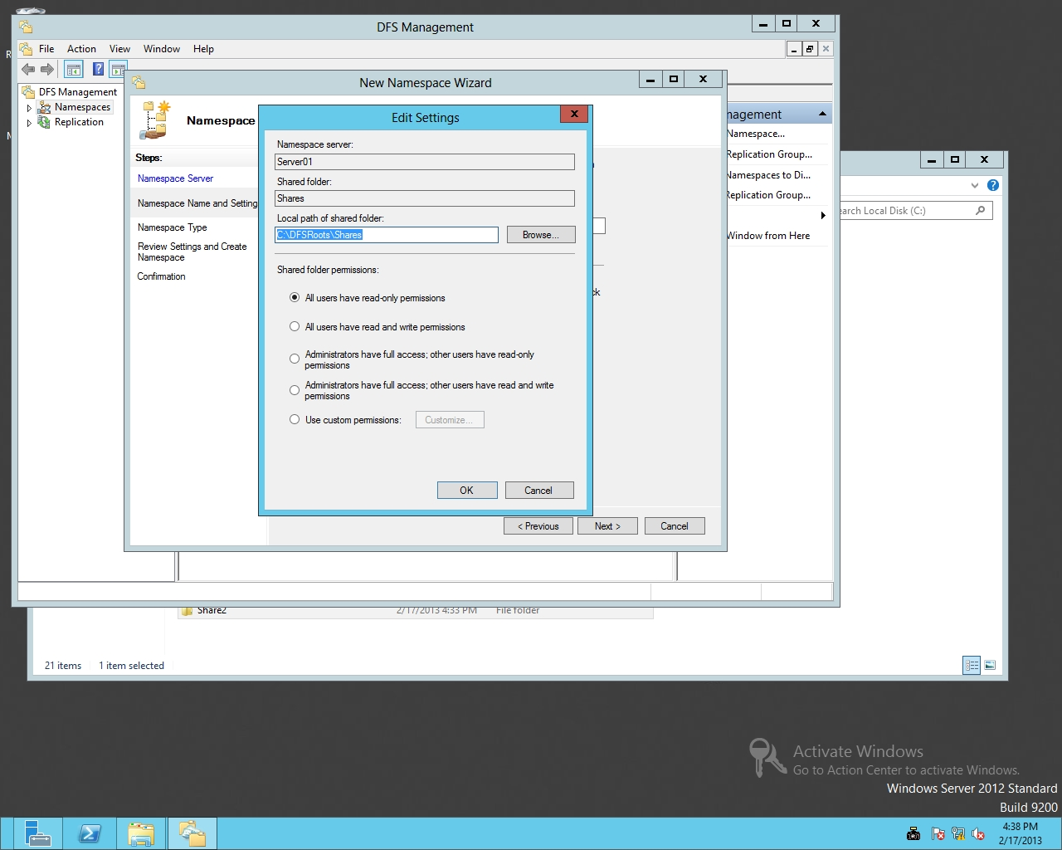

Figure 4-1

Specifying Share permissions for a DFS namespace

|  |  |
| --- | --- |
| Question 2 | What is the default location for the shares folder? |

**15.** Click *All users have read and write permissions*. Click OK to close the Edit Settings dialog box.

**16.** On the Namespace Name and Settings page, click Next.

|  |  |
| --- | --- |
| Question 3 | What is the name of the domain-based namespace? |

**17.** On the Namespace Type page, with Domain-based namespace already selected and Windows Server 2008 mode selected (as shown in Figure 4-2) click Next.

|  |  |
| --- | --- |
| Question 4 | What is the advantage of Windows Server 2008 mode? |

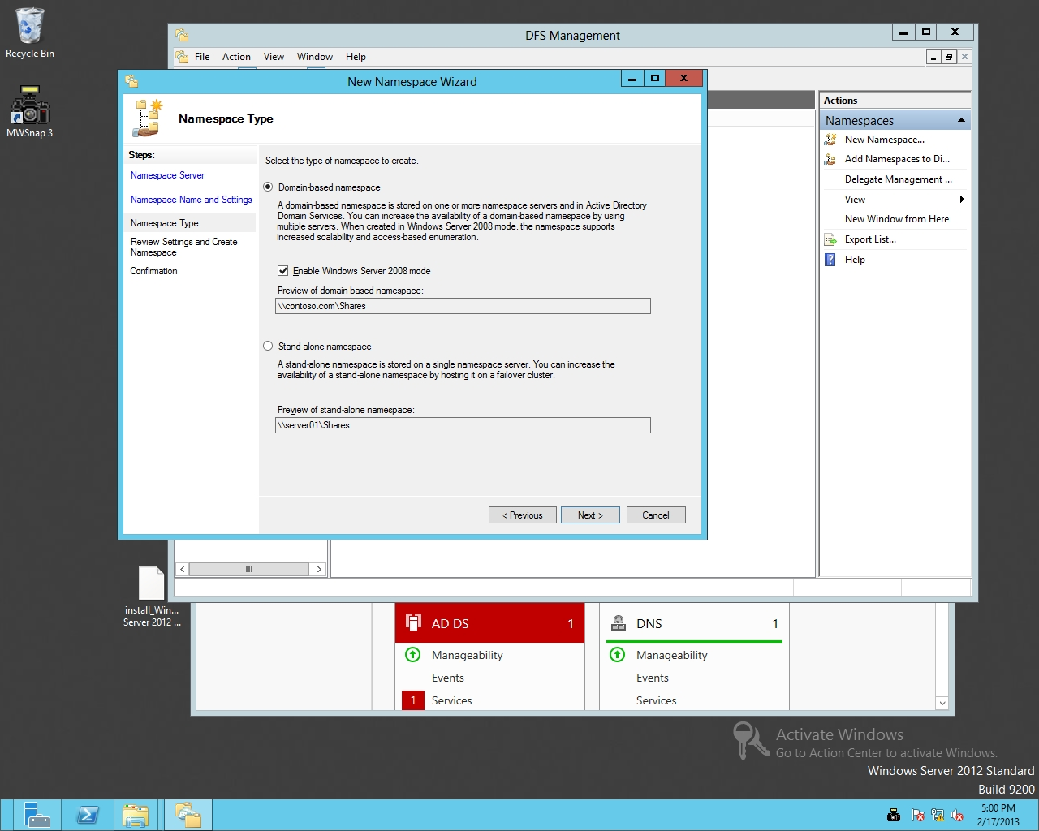

Figure 4-2

Selecting the type of namespace

**18.** On the Review Settings and Create Namespace page, click Create.

**19.** When the name space is created, click the Close button.

**20.** On the DFS Management console, in the left pane, expand the Namespaces node and click \\contoso.com\Shares.

**21.** Under Actions, click New Folder, as shown in Figure 4-3. The New Folder dialog box opens.

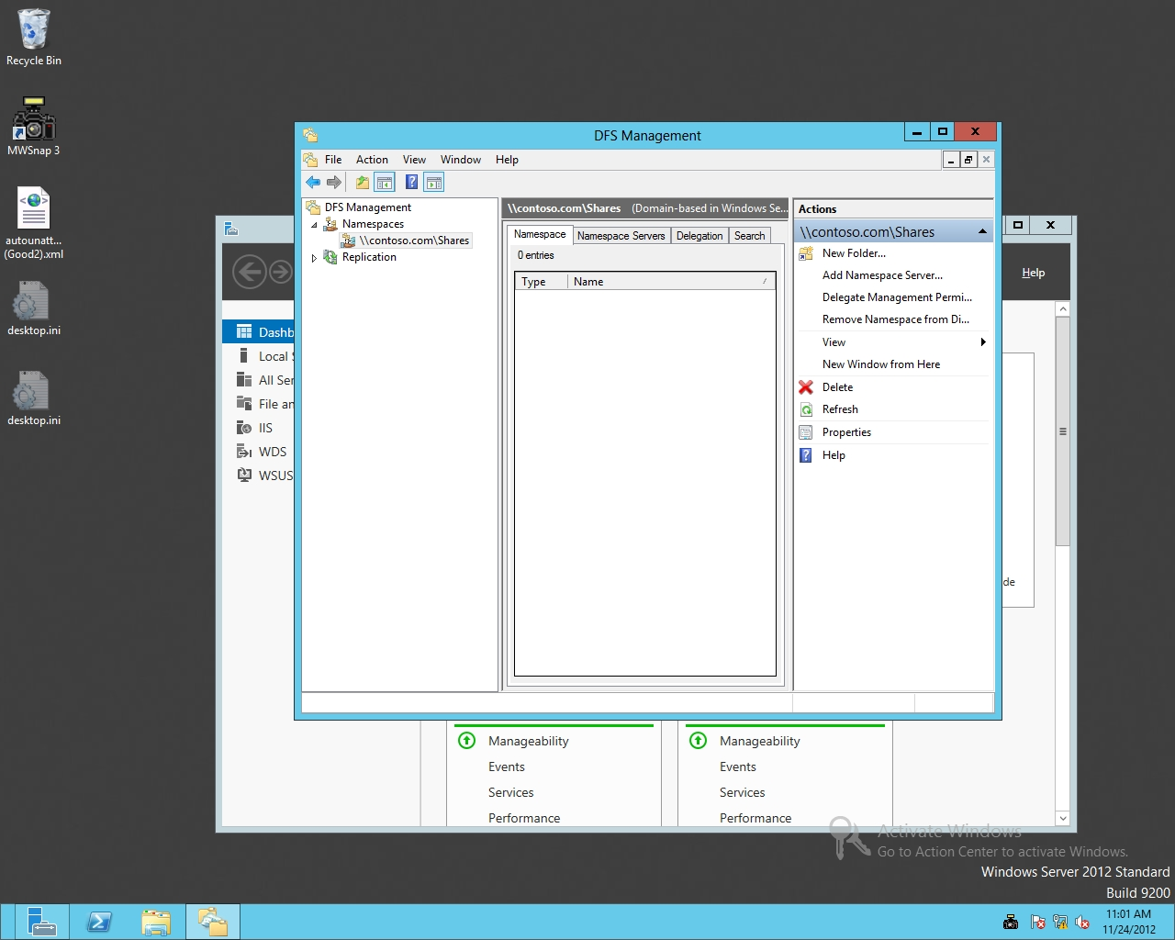

Figure 4-3

The DFS Management console with available actions

**22.** Type **Server01 Share1** in the Name text box.

**23.** To specify the shared folder, click Add.

**24.** In the Add Folder Target dialog box, type **\\Server01\Share1** in the Path to folder target text box. Click OK to close the Add Folder Target dialog box.

**25.** Click OK to close the New Folder dialog box.

**26.** Under Actions, click New Folder. Create a new folder called **Server01 Share2** that points to \\Server01\Share2. Click OK. Click OK, again.

**27.** Under Actions, click New Folder. Create a new folder called **Server02 Share1** that points to \\Server02\Share1. Click OK, twice

**28.** Under Actions, click New Folder. Create a new folder called **Server02 Share2** that points to \\Server02\Share2. Click OK, twice.

**29.** On Server01, open a File Explorer window and type **\\contoso.com\shares** in the location text box and press Enter. See Figure 4-4.

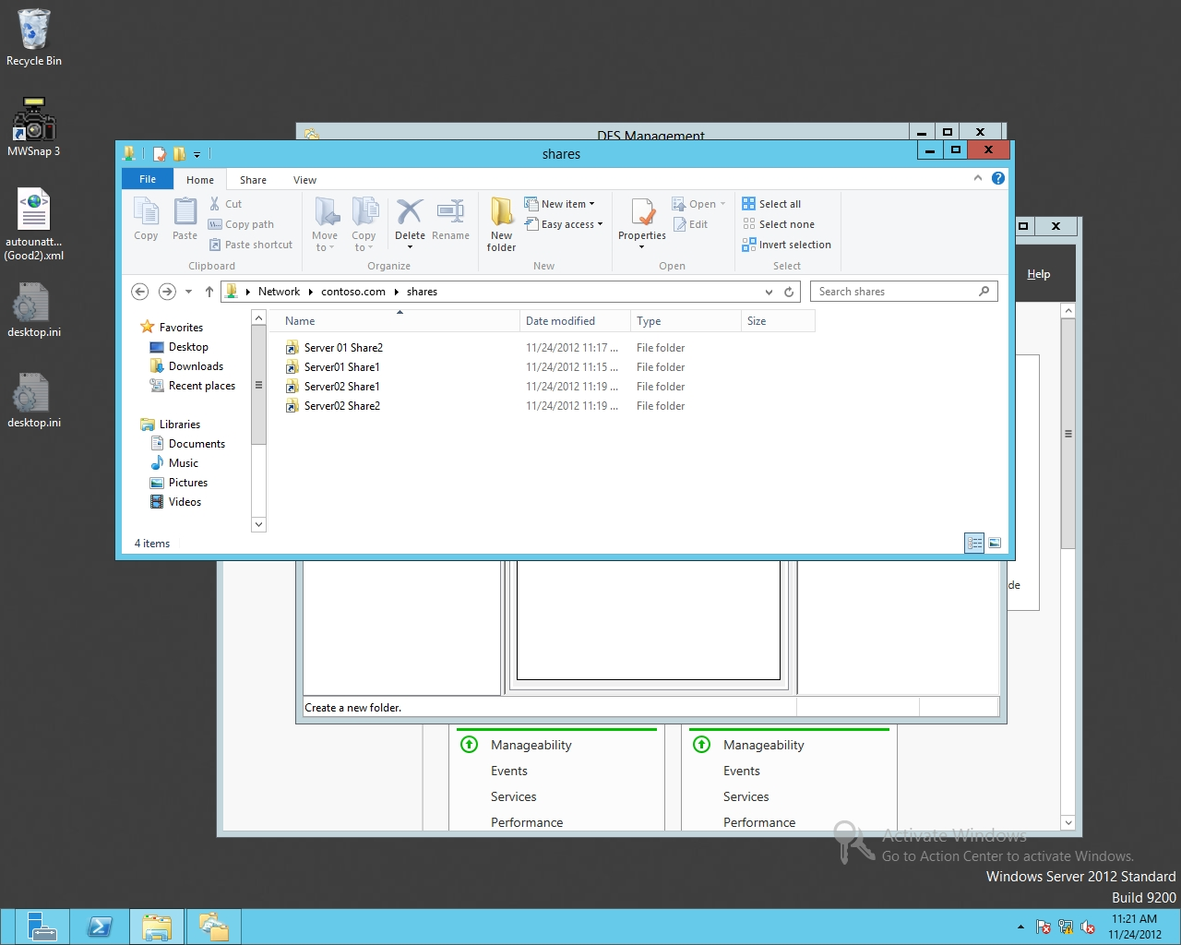

Figure 4-4

Accessing a namespace

**30.** Close File Explorer.

**31.** On the DFS Management console, right-click the\\contoso.com\Shares namespace and click Properties. The Properties dialog box opens.

**32.** Click the Advanced tab.

**33.** Click to select *Enable access-based enumeration for this namespace*.

**34.** Take a screen shot of the \\contoso\com\Shares Properties dialog box by pressing Alt+Prt Scr and then paste it into your Lab04_worksheet file in the page provided by pressing Ctrl+V.

|  |  |
| --- | --- |
| Question 5 | What does the Enable access-based enumeration for this namespace option do? |

**35.** Click OK to close the Properties dialog box.

End of exercise. Close any open windows before you begin the next exercise.

|  |  |
| --- | --- |
| Exercise 4.3 | Configuring DFS Replication |
| Overview | During this exercise, you configure two folders, each on a different server. You then configure DFS to replicate the content of one folder to the other server. |
| Completion time | 10 minutes |

**Mindset Question: You have a project folder that must be available in New York and Paris. Some of these files take some time to open over a slow WAN link, because of their size. What can you do to help alleviate this?**

**1.** On Server01, create a **C:\Share3** folder. Share the folder as Share3. Assign Allow Full ControlShare permissions to Everyone.

**2.** On Server02, create a **C:\Share3** folder. Share the folder as Share3. Assign Allow Full ControlShare permissions to Everyone.

**3.** On Server01 DFS Management console, right-click Replication and select New Replication Group.

**4.** On the Replication Group Type page, click Next.

**5.** On the Name and Domain page, type **Rep1** in the Name of replication group text box. Click the Next button.

**6.** On the Replication Group Members page, click the Add button.

**7.** When the Select Computers dialog box opens, type **Server01** in the Enter the object names to select text box and click OK. If it asks you to enter a network password, specify **Contoso\Administrator** and password of **Password01**.

**8.** Click Add and add Server02.

**9.** Take a screen shot of the New Replication Group Members page by pressing Alt+Prt Scr and then paste it into your Lab04_worksheet file in the page provided by pressing Ctrl+V.

**10.** Back on the Replication Group Members page, click Next.

**11.** On the Topology Selection page (as shown in Figure 4-5), click Next.

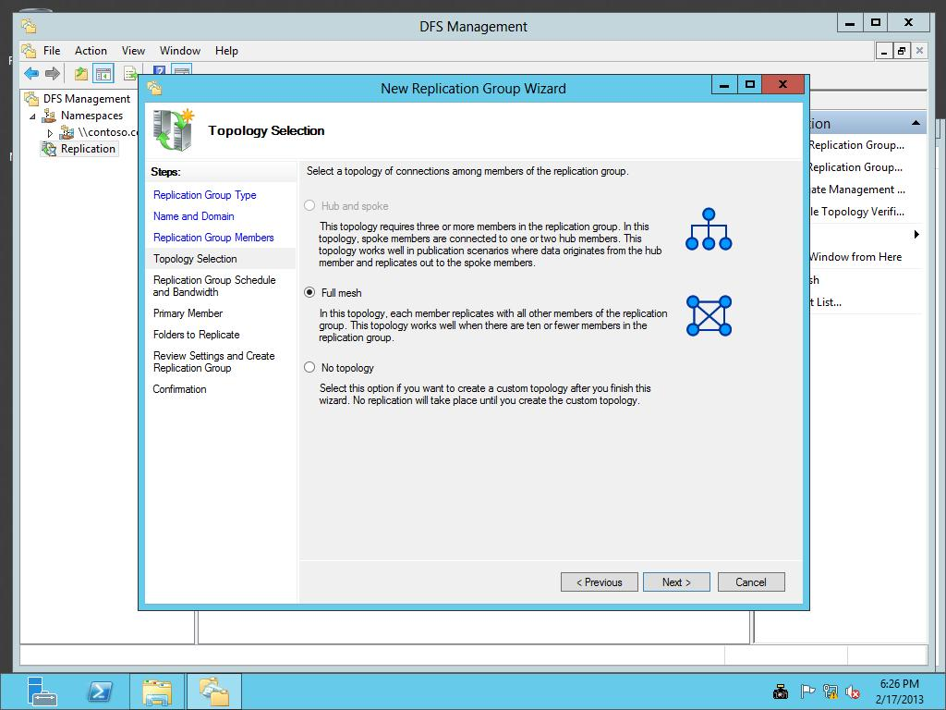

Figure 4-5

Selecting the DFS topology

**12.** On the *Replication Group Schedule and Bandwidth* page, click Next.

**13.** On the Primary Member page, select Server01 as the Primary member. Click Next.

**14.** On the Folders to Replicate page, click Add.

**15.** When the Add Folder to Replicate dialog box opens, type **C:\Share3** in the Local path of folder to replicate text box and click OK.

**16.** Back on the Folders to Replicate page (as shown in Figure 4-6), click Next.

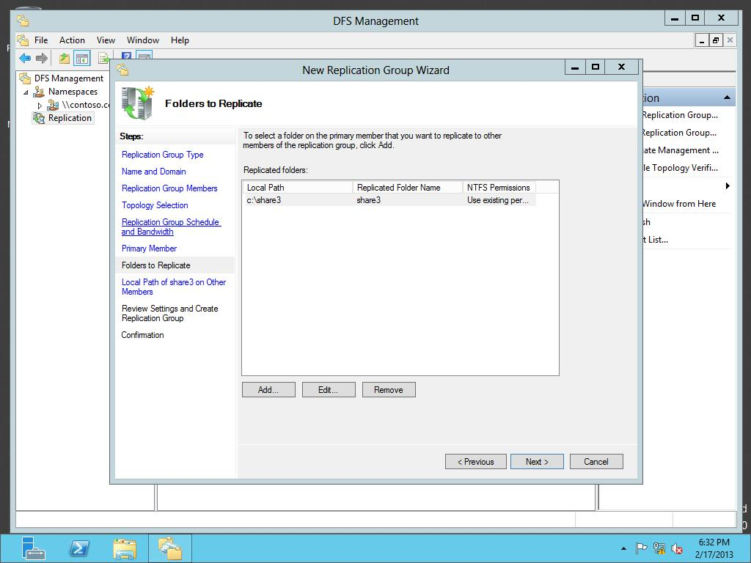

Figure 4-6

Adding folders to replicate

**17.** On the Local Path of Share3 on Other Members page, with Server02, click Edit.

**18.** Click Enabled and type **C:\Share3** in the Local path of folder text box as shown in Figure 4-7. Click OK to close the Edit dialog box.

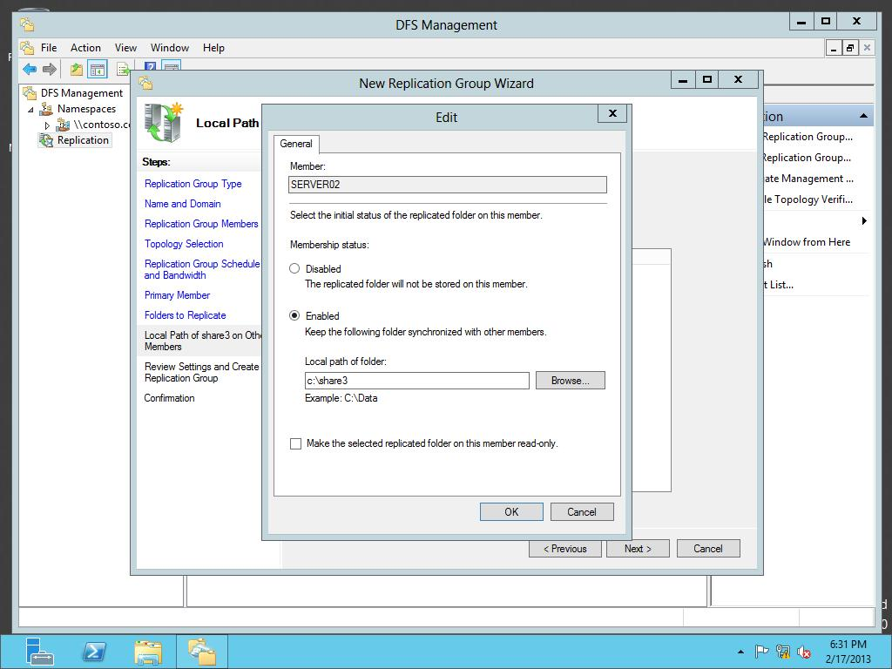

Figure 4-7

Accessing a namespace

**19.** Back on the Local Path of Share3 on Other Members page, click Next.

**20.** On the *Review Settings and Create Replication Group* page, click Create.

**21.** When the replication group has been created, click Close.

**22.** If you get a Replication Delay message, click OK.

**23.** Click the Repl node and take a screen shot of the DFS Replication by pressing Alt+Prt Scr and then paste it into your Lab04_worksheet file in the page provided by pressing Ctrl+V.

**24.** On Server01, open the C:\Share3 folder.

**25.** Right-click the opened folder, click New and click Text Document. Name the document **Doc1.txt**.

**26.** Open the Doc1.txt file and type your name. Save and close the text document.

**27.** On Server02, open the C:\Share3 folder and verify that the Doc1 has replicated to Server02. It may take a minute or two to replicate.

Lab REview Questions

|  |  |
| --- | --- |
| **Completion time** | **5 minutes** |

**1.** In Exercise 4.2, what technology was used to create a shared folder of shared folders?

**2.** In Exercise 4.2, where is the configuration for domain-based namespaces stored?

**3.** In Exercise 4.2, what technology is used to automatically copy files from one server to another?

**4.** In Exercise 4.2, what topology is used to have files replicate from one member to all other DFS members?

|  |  |
| --- | --- |
| Lab Challenge | Create a Fault-Tolerant Shared Folder |
| Overview | To complete this challenge, create a high-level list to create a fault-tolerante shared folder by writing the steps to complete the tasks described in the scenerio. |
| Completion time | 10 minutes |

You have content that is contained in a folder that you want to make available, even if a file server becomes unavailable. What do you need to do to accomplish this?

Write out the steps you performed to complete the challenge.

End of lab. You can log off or start a different lab. If you want to restart this lab, you’ll need to click the End Lab button in order for the lab to be reset.